Primate Anatomy

* Primate hands and feet are adapted for grasping
* Opposable big toes and thumbs

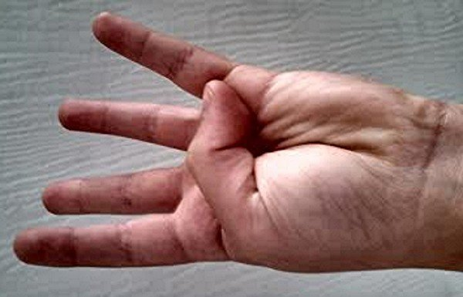

* Flat nails, not claws
  + Thinner

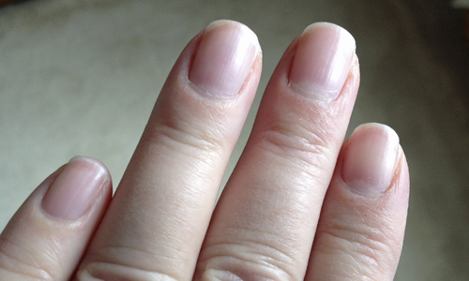

* Locomotions in hindlimb dominated (bipedialism)

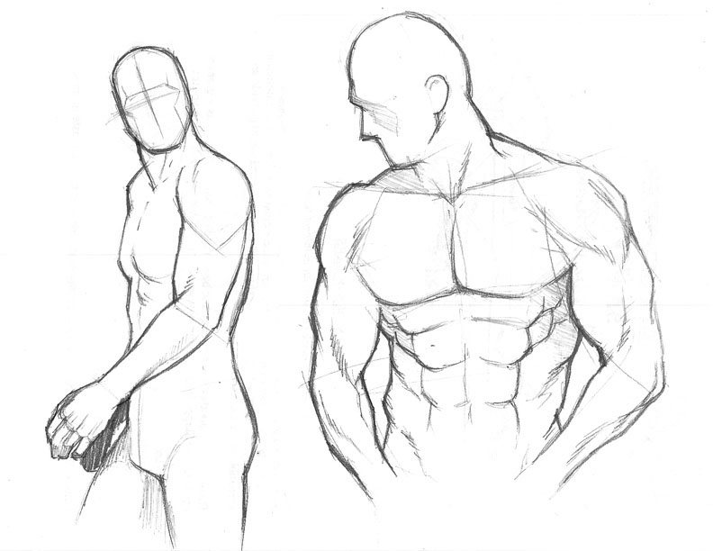

* Primates have improved vision and a reduced sense of smell
  + Dry nose
    - Duller sense of smell
  + Wet nose
    - Helps animals smell better
  + Eyes face forward
    - More field of vision forward facing
    - **Stereoscopic vision**: the single perception of a slightly different image from each eye, resulting in depth perception

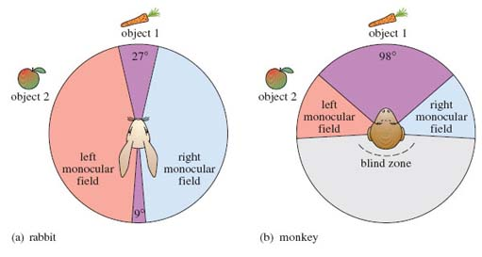

* + - Depth perception is present in forward facing visions
    - Possibly because predators have forward facing vision
    - However primates are not primarily predators though (on other larger primates)
* Primates have a slower life history than similarly-sized mammals
  + Small litters
  + Longer pregnancy, juvenile period, and lifespan
  + **More nurturing**
    - Reduction in mortality
    - Generally done by the female in the species because the male can produce nearly an infinite amount of offspring whereas the female gets one shot
  + Primates have a generalized dentition
    - **Generalized Dentition:**  primates teeth differ in size and shape, in fact we have four different kinds of teeth in our mouths
      * Basically there are teeth that do specialized tasks and are arranged in specific places

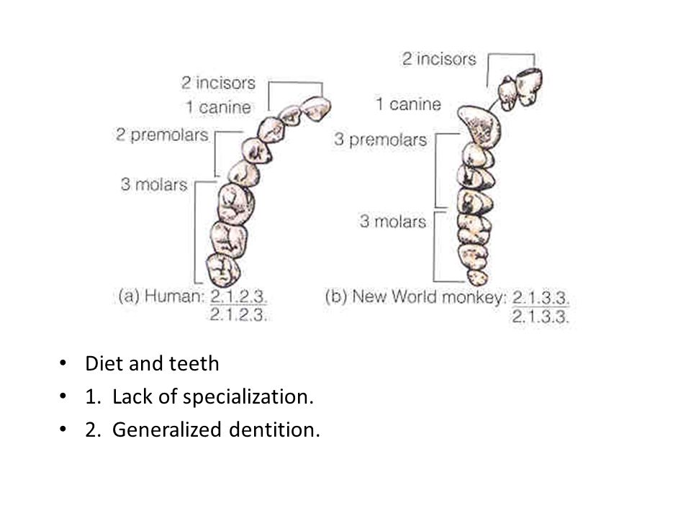

* + - * Memorize the order in which the specialization occurs